ADVANCED DATA STRUCTURE

GROUP F

ASSIGNMENT 13

YEAR: 2016-17

COLLEGE: VIIT

DATE OF COMPLETION : 30/03/2018

**Aim:**

Write a Java program which will demonstrate a concept of Interfaces and packages: In this assignment design and use of customized interfaces and packages for a speciﬁc application are expected.

**Objective:**

To make use of Interfaces and packages in JAVA.

**Software And Hardware Requirement:**

1. 64-bit Open source Linux or its derivative.

2. Eclipse IDE or NetBeans IDE.

**Theory:**

1 Interface

An interface in java is a blueprint of a class. It has static constants and abstract methods. The interface in java is a mechanism to achieve abstraction. There can be only abstract methods in the java interface not method body. It is used to achieve abstraction and multiple inheritance in Java. Java Interface also represents IS-A relationship. It cannot be instantiated just like abstract class. Why use Java interface? There are mainly three reasons to use interface. They are given below.

It is used to achieve abstraction. By interface, we can support the functionality of multiple inheritance. It can be used to achieve loose coupling. Understanding relationship between classes and interfaces As shown in the ﬁgure given below, a class extends another class, an interface extends another interface but a class implements an interface.

Multiple inheritance in Java by interface If a class implements multiple interfaces, or an interface extends multiple interfaces i.e. known as multiple inheritance.

2 Package

A java package is a group of similar types of classes, interfaces and sub-packages. Package in java can be categorized in two form, built-in package and user-deﬁned package. There are many built-in packages such as java, lang, awt, javax, swing, net, io, util, sql etc.

Here, we will have the detailed learning of creating and using user-deﬁned packages. Advantage of Java Package 1) Java package is used to categorize the classes and interfaces so that they can be easily maintained. 2) Java package provides access protection. 3) Java package removes naming collision. How to access package from another package? There are three ways to access the package from outside the package. 1)import package.*; 2)import package.classname; 3)fully qualiﬁed name.

**Algorithm:**

START :

1.Firstly Create Three Interfaces Namely Personal Professional and Acadamic separetaly in one package named as Records.

2.Each Interface contains accept() and display() method declarations.

3.Then Create Another Class named Employee which has main() fuction

4.Then Deﬁne the accept() and display() method to accept and display information of employee.

5.In main(),create objects of Employee Class.

6.Then Accept Each Information of Employee by using accept() method.

7.And Finally Display All The Information of employee..

END .

**Code :**

**package** ads.assignments.clients;

**import** ads.assignments.servers.Assignment13InterfacesPackages;

**public** **class** Assignment13InterfacesPackagesClient {

**public** **static** **void** main(String[] args) {

Assignment13InterfacesPackages aObj = **new** Assignment13InterfacesPackages();

aObj.accept();

aObj.display();

}

}

**package** ads.assignments.interfaces;

**public** **interface** Accept {

**void** accept();

}

**package** ads.assignments.interfaces;

**public** **interface** Display {

**void** display();

}

//Write a java program that demonstrates a concept intefaces and packages.

//In this assignment use of customized package and interfaces is for specific application is expected

package ads.assignments.servers;

import java.util.Scanner;

import ads.assignments.interfaces.Accept;

import ads.assignments.interfaces.Display;

public class Assignment13InterfacesPackages implements Accept, Display{

String name, mobile, curclass, division, rollno;

@Override

public void display() {

System.out.println("----------STUDENT INFORMATION----------");

System.out.println("NAME : " +name);

System.out.println("CLASS : " +curclass);

System.out.println("DIVISION : " +division);

System.out.println("ROLL NO : " +rollno);

System.out.println("MOBILE : " +mobile);

}

@Override

public void accept() {

Scanner sc = new Scanner(System.in);

System.out.print("\nENTER NAME : ");

name = sc.next();

System.out.print("\nENTER CLASS : ");

curclass = sc.next();

System.out.print("\nENTER DIVISION : ");

division = sc.next();

System.out.print("\nENTER ROLLNO : ");

rollno = sc.next();

System.out.print("\nENTER MOBILE : ");

mobile = sc.next();

}

}

**Output:**

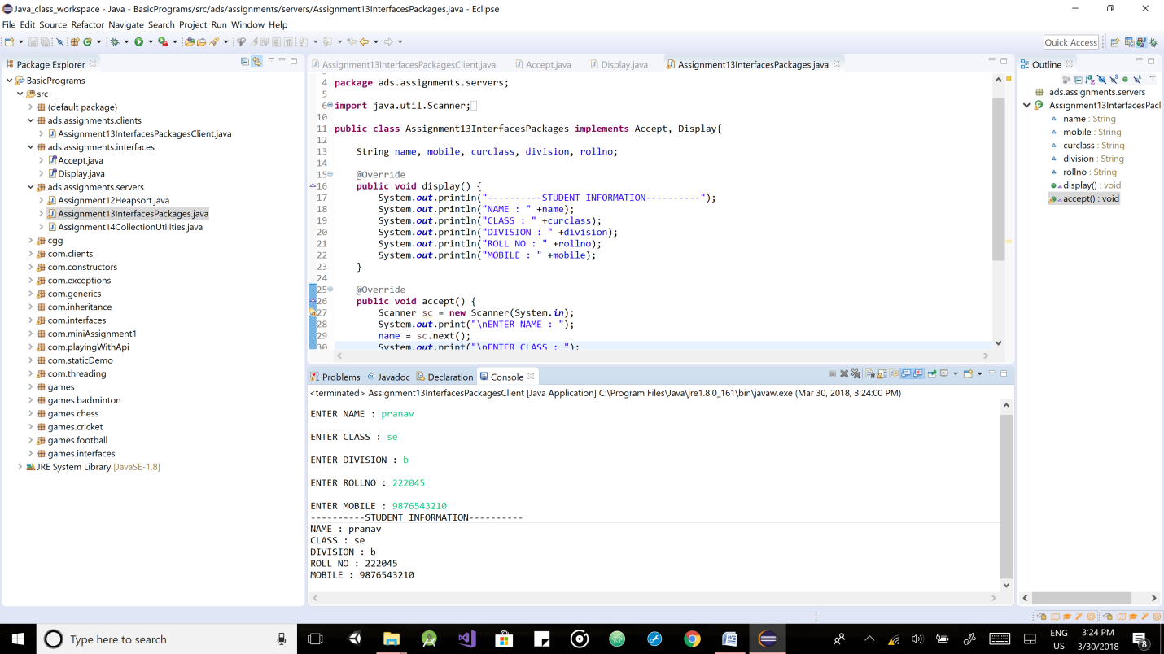

**Conclusion:**

Concept of interfaces and packages learnt in java.